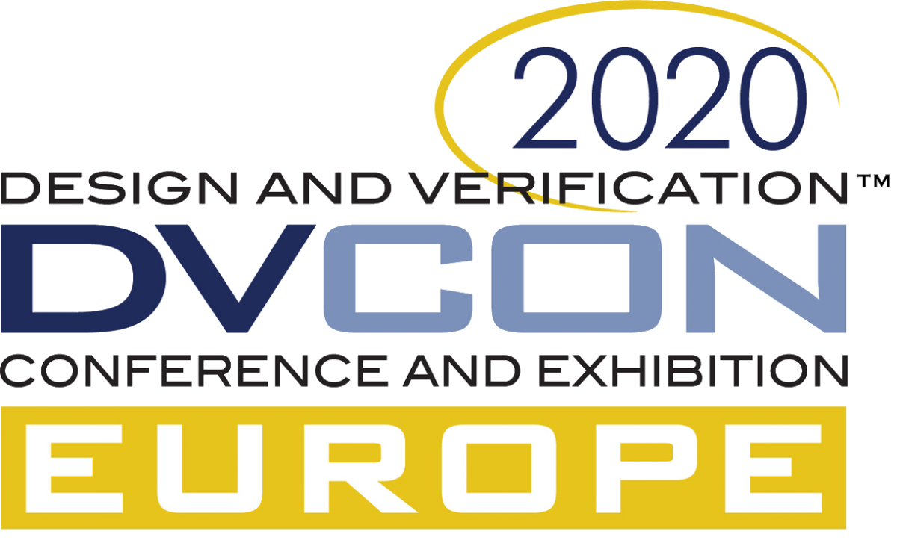

DVCon Europe Announces 2020 Dates and Calls For Papers, Tutorials And Panels
Aims to strengthen collaboration between experts in software, hardware and system-level design

Munich, Germany – March 25th, 2020 - The Design and Verification Conference & Exhibition Europe (DVCon Europe), sponsored by Accellera Systems Initiative, has announced the call for papers, tutorials and panels for the next conference, which will be held at the Holiday Inn Munich City Centre, on October 27th and 28th, 2020. Following last year’s successful broadening of scope to include embedded software, the aim this year is to strengthen collaboration between software, hardware and system-level design experts. The deadline for initial submissions is April 27th.
The event is in its seventh year and in 2019, once again, registrations increased 20% year-on-year. The SystemC Evolution Day will again be held at the same venue on the following day, October 29th.
For the second year running, the General Chair of DVCon Europe is Joachim Geishauser. Geishauser has played an active role since the launch of DVCon Europe, having acted as Panel Chair and Tutorial Chair in previous years. The DVCon Europe 2020 Steering Committee is composed of technical experts from NXP, Intel, Bosch Sensortec, ARM, Infineon, Ericsson and Qualcomm, ensuring that DVCon Europe is made by users for users.
“Last year we added embedded software to the programme, as part of our plan to address the system-level design, modeling and verification complexity of today’s embedded systems,” noted Geishauser. “The challenges remain, and DVCon Europe is the perfect event to gather hardware, software and system engineers together to address these multi-disciplinary challenges. Our ambition is to further strengthen the collaboration and interaction between the software, hardware and system-level experts, and jointly develop the standards and methodologies required to design and verify the products of the future.”
The 2020 conference invites papers, tutorials and panels on a range of subjects, including special interest areas such as digital twin, machine learning, RISC-V, next generation automotive and 5G. Submissions are also welcome in areas such as system-level and software design, model-based and model-supported software design, verification and validation, IP reuse and design automation, functional safety and security, and mixed-signal and low-power design and verification.
Note regarding Coronavirus
The DVCon Europe Steering Committee will be closely monitoring the Coronavirus situation and if necessary the format of the conference will be adjusted.
ABOUT DVCON EUROPE
The Design and Verification Conference & Exhibition in Europe (DVCon Europe) is the leading European event covering the application of languages, tools and intellectual property for the design and verification of electronic systems and integrated circuits. Sponsored by Accellera Systems Initiative, and one of several DVCon events around the globe (see below), DVCon Europe brings chip architects, design & verification engineers, and IP integrators the latest methodologies, techniques, applications and demonstrations for the practical use of EDA solutions for electronic design. For more details, visit www.dvcon-europe.org. Follow #dvconeurope on Twitter.
ABOUT ACCELLERA SYSTEMS INITIATIVE
Accellera Systems Initiative (Accellera) is an independent, not-for profit organization, dedicated to create, support, promote and advance system-level design, modeling and verification standards for use by the worldwide electronics industry. The organization accelerates standards development and, as part of its ongoing partnership with the IEEE, its standards are contributed to the IEEE Standards Association for formal standardization and ongoing change control. For more information, please visit accellera.org. For membership information, please email membership@accellera.org. Follow @accellera on Twitter or to comment, please use #accellera.
ACCELLERA GLOBAL SPONSORS: Cadence; Mentor, A Siemens Business; Synopsys
# # #
Accellera Systems Initiative and DVCon are trademarks of Accellera Systems Initiative Inc. All other trademarks and trade names are the property of their respective owners.

Editorial Contact:
Annette Bley
Annette Bley PR
Phone: +44 (0) 7973 801132
Email: annette@annettebleypr.com

